Play in the upper rudder bearing

Diana: We replaced the lower rudder bearing, bronze bush, the winter before last, but now find that there is quite a lot of play in the upper bearing. We bought a replacement white Teflon from DF dealer. When we tried to fit it we realised that the inside diameter of the bearing is too small to accommodate the rudder stock. We have been told that the factory advice is to remove the rudder completely and press the new bearing home into the top of the housing. Then you are supposed to machine this out to the correct diameter and push the rudder stock back into position through the new bearing from beneath.
Apparently the bearing needs to be so thin that it will break when you install it if bored out to the correct size beforehand.
____________________________________________________________________________________
Mika Harju: You need to take the bearing housing to a machine workshop where it needs to be machined to the right diameter with a lathe. You need to measure the accurate diameter of the shaft with a vernier caliper or take it with you. I do recommend a bronze bearing ring instead of a plastic one because it will last longer and needs a smaller play between the shaft and bearing.

Mal: Did you go into the afterpeak till the end. In my boat i find the upper support of the rudder brake

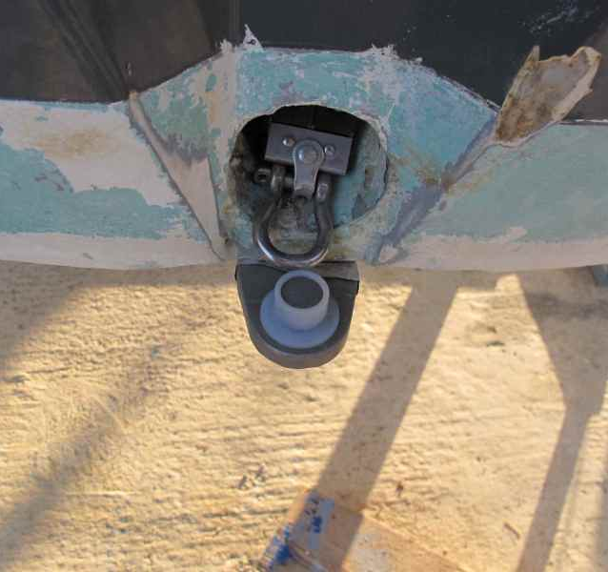
Téton Ø16
Bague (1) Ø19
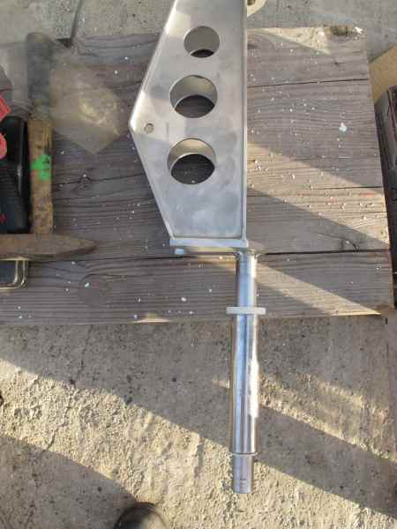
Diamètre trou dans plaque inférieure recevant bague (1) : 19.5mm

Mêche Ø=25 mm
« 24.996 »
Tube inox Longueur sans bague=153 mm
Øext=33.5 mm
Øint= 29 ?
Bagues (3a et 3b)
Hauteur= 25mm
Epaisseur colerette: 3mm
Diametre colerette inf. 40mm

19.5mm
Bague 3a
Bague 3b

________________________________________________________________________________
Diana: We have now done the job and have successfully reinstalled the rudder housing. The shaft is much firmer in the new bearings. Actually once you get to grips with the thing it's not a difficult job really. Al Wood, the UK agent had the bearings which we then got machined to size as they come as oversized blanks. Al also has the bronze bush to fit the bottom bearing and that came correctly sized for our needs.
Mal: Diana;- did you use the DF plastic bearing, or have a bronze one made? If the plastic DF one, did you get it machined by a machine shop & take the rudder shaft with you to make sure it fits? Bit of a pain that you've got to have the boat out of the water to do the job, as need to unbolt rudder housing mounting strap from the bottom of the hull? Did you re-install rudder housing/shaft, and then tap the new bearing down the shaft and into the deck hole to avoid breaking the new bearing?
Diana: We bought two hard plastic bearings from Al Wood. They are the DF supplied ones. They come as shaped, but oversized pieces and we got them machined down to fit by a workshop. the guy said he had needed to do it more slowly that he'd expected as the plastic got hotter than he's used to.
We took the rudder tube and the shaft/rudder bracket to the workshop so he could size everything correctly.
Our tube came back with the white plastic bearings tightly fitted in the top and bottom ends and the shaft able to slip smoothly into the tube and new bearings. The machine shop also cleaned the old epoxy off the outside of the tube so it went back down the hole in the boat quite simply from the top just by pushing with fingers. One of us held the tube still whilst the other climbed down through the floor hatch and got into the back of the boat. We applied some plastic padding marine epoxy from the inside with a wooden lolly stick so that the tube is bonded into position. It's a fairly easy job to then feed the shaft/rudder bracket up from below and refit the bottom plate. We used the bronze top hat shaped bearing as supplied by Al Wood to complete the assembly of the lower plate. We applied some Sikaflex to bed of the plate and tightened the hex head screws with a torque wrench, and then screwed the retaining bracket back on at the top of the shaft.
PS The original plastic bearings were glued into the tube, which would make it almost impossible to remove them without taking the tube out of the boat. In fact, when we tried to remove the plastic bearings the tube came loose and we drove the whole assembly out with a large socket and an extension piece and it dropped out of the bottom of the housing onto the ground.
Later on, We had a problem with the plastic bushing at the top of the tube. After a few miles of sailing we have found that the upper bush has been working its way up and out of the stainless tube towards the tiller connection. We have bought some Locktite products to glue the plastic to the stainless. It clearly needs to be very well glued in. As yet we are not sure it is solved. So if you plan to do this job, make sure you have a product which will bond the bearing material into the tube very strongly.

